SHIFT - Certificates Strategy
Certificates sit between Badges and NFTs in the SHIFT reward stack. Badges are the daily proof-of-work layer (small, frequent, +0.05–0.15x). Certificates are achievement memorabilia earned for distinctive results, rare, and designed for social sharing. NFTs sit on top as long-horizon collectibles with the biggest bonuses.
Reward stack at a glance
Badges → fast, common, capped Dynamic bonus at +2.0x (Hall of Fame is the only Permanent exemption). Certificates → rare, share-worthy, mixed Dynamic / Permanent, stacked on top of badges but inside the same multiplier ceiling unless explicitly off-ceiling. NFTs → premium, long-hold cosmetic + bonus layer.
Five Categories
1. Seasonal Rankings - paired with Gold
Awarded at season end (~12 weeks). Reset every season. Highest social value because they're competitive and time-bound.
Certificate | Earned by | Bonus logic | Scarcity / cap
Top 1% Trader | Finish season in top 1% of leaderboard. | +0.30x Dynamic · 2 seasons | ≈ 280 wallets / season
Top 10% Trader | Finish season in top 10%. | +0.20x Dynamic · 1 season | ≈ 2,800 / season
Top 25% Trader | Finish season in top 25%. | +0.10x Dynamic · 1 season | ≈ 7,000 / season
Most Profitable PnL | Highest realized PnL of the season. | +0.25x Dynamic · 1 season | 1 / season
Most Active Trader | Highest verified trade volume of the season. | +0.15x Dynamic · 1 season | 1 / season
2. Tier Holders - paired with Teal (badge tier echo)
Crystallizes a wallet's badge tier into a permanent certificate. Issued the first time a wallet hits each tier - soulbound after that.
Certificate | Earned by | Bonus logic | Scarcity / cap
Platinum Member | Reached Platinum tier (5+ Platinum badges). | +0.20x Permanent | Uncommon
Gold Member | Reached Gold tier (5+ Gold badges). | +0.10x Permanent | Common
Silver Member | Reached Silver tier (5+ Silver badges). | +0.05x Permanent | Common
3. Mastery Cards - paired with Silver
Skill-based achievements that recognize traders for behavior, not outcomes. These reward the things SHIFT wants to encourage.
Certificate | Earned by | Bonus logic | Scarcity / cap
Iron Stomach | Held a leveraged position through a -30%+ drawdown without closing. | +0.15x Dynamic | Rare
Diamond Hands | Held same position for 180+ consecutive days. | +0.20x Dynamic | Rare
Comeback Kid | Recovered from a -50%+ portfolio drawdown to a new high. | +0.25x Dynamic | Very rare
4. Personality Series - paired with Amber
Six archetype cards inspired by Michael's request for personality-driven badges (Saylor / Trump / Elon energy) - but rendered as archetypes, not named individuals. This avoids right-of-publicity risk and keeps the cards evergreen even if a real-world figure becomes controversial. Each card is cosmetic-only (no bonus on the card itself). The bonus lives on the meta-card.
Certificate | Earned by | Bonus logic | Scarcity / cap
The Maxi | 90+ day leveraged long held through a -20%+ drawdown without closing. | Cosmetic only | Uncommon
The Big Short | Profitable short during -10%+ index drawdown, closed at +30% or better. | Cosmetic only | Uncommon
The Maverick | Held a small-cap / innovation long through a +50%+ run. | Cosmetic only | Uncommon
The Macro | Opened a Fed-Day position that closed +10% or better within 30 days. | Cosmetic only | Uncommon
The Compounder | Same blue-chip long held 180+ days, never trimmed. | Cosmetic only | Uncommon
The Whale Hunter | Single position ≥10% of cumulative volume, held 30+ days, closed profitably. | Cosmetic only | Rare
Meta-card · The Investor
Holding all 6 Personality cards unlocks The Investor - a soulbound meta-card with +1.15x Permanent that sits OFF-CEILING (the only exemption besides Hall of Fame). This is the collection mechanic: the cosmetic cards drive social sharing, the meta-card pays.
Summary - 21 Certificates
Category | Count | Bonus profile
Seasonal Rankings | 5 | Dynamic, resets each season
Tier Holders | 3 | Permanent, soulbound on first earn
Mastery Cards | 3 | Dynamic, behavior-based
Lifetime & Veteran | 3 | Permanent, soulbound
Personality Series | 6 + 1 meta | Cosmetic + 1 off-ceiling meta

Hero Mockups - 6 Cards in the SHIFT Visual System
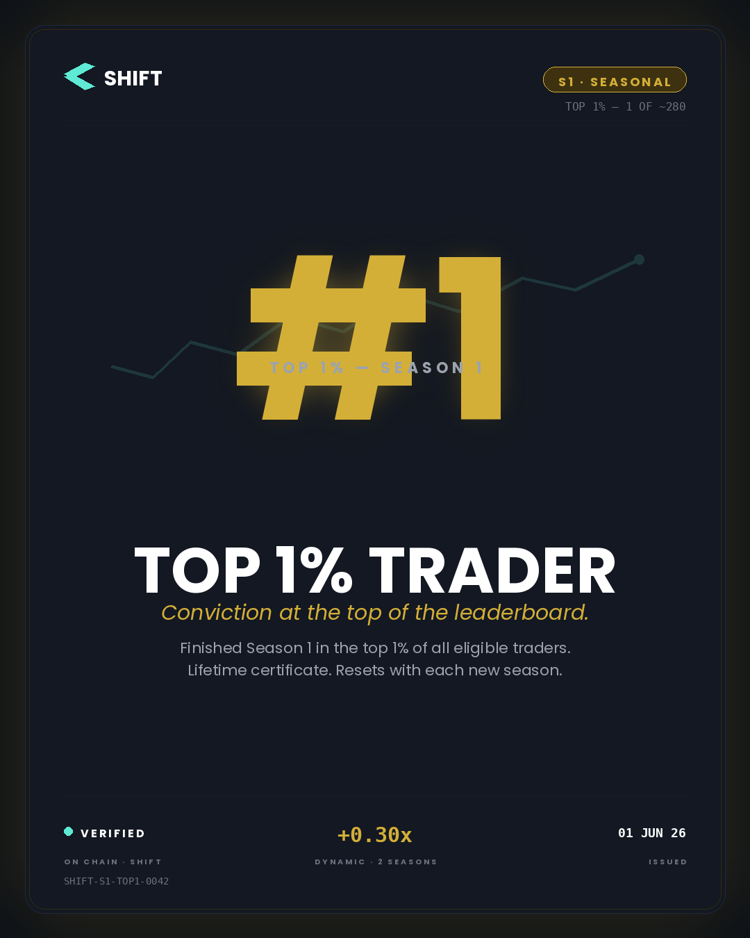 | 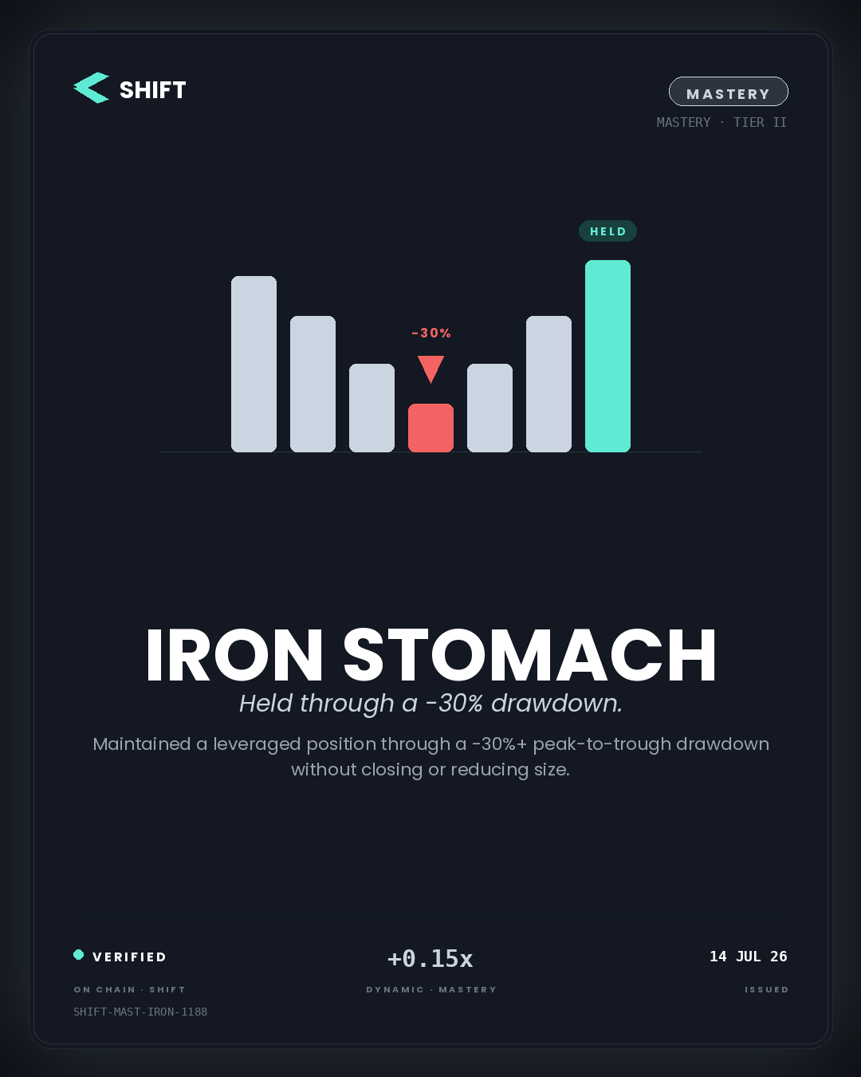
Top 1% Trader · Seasonal · paired with Gold | Iron Stomach · Mastery · paired with Silver
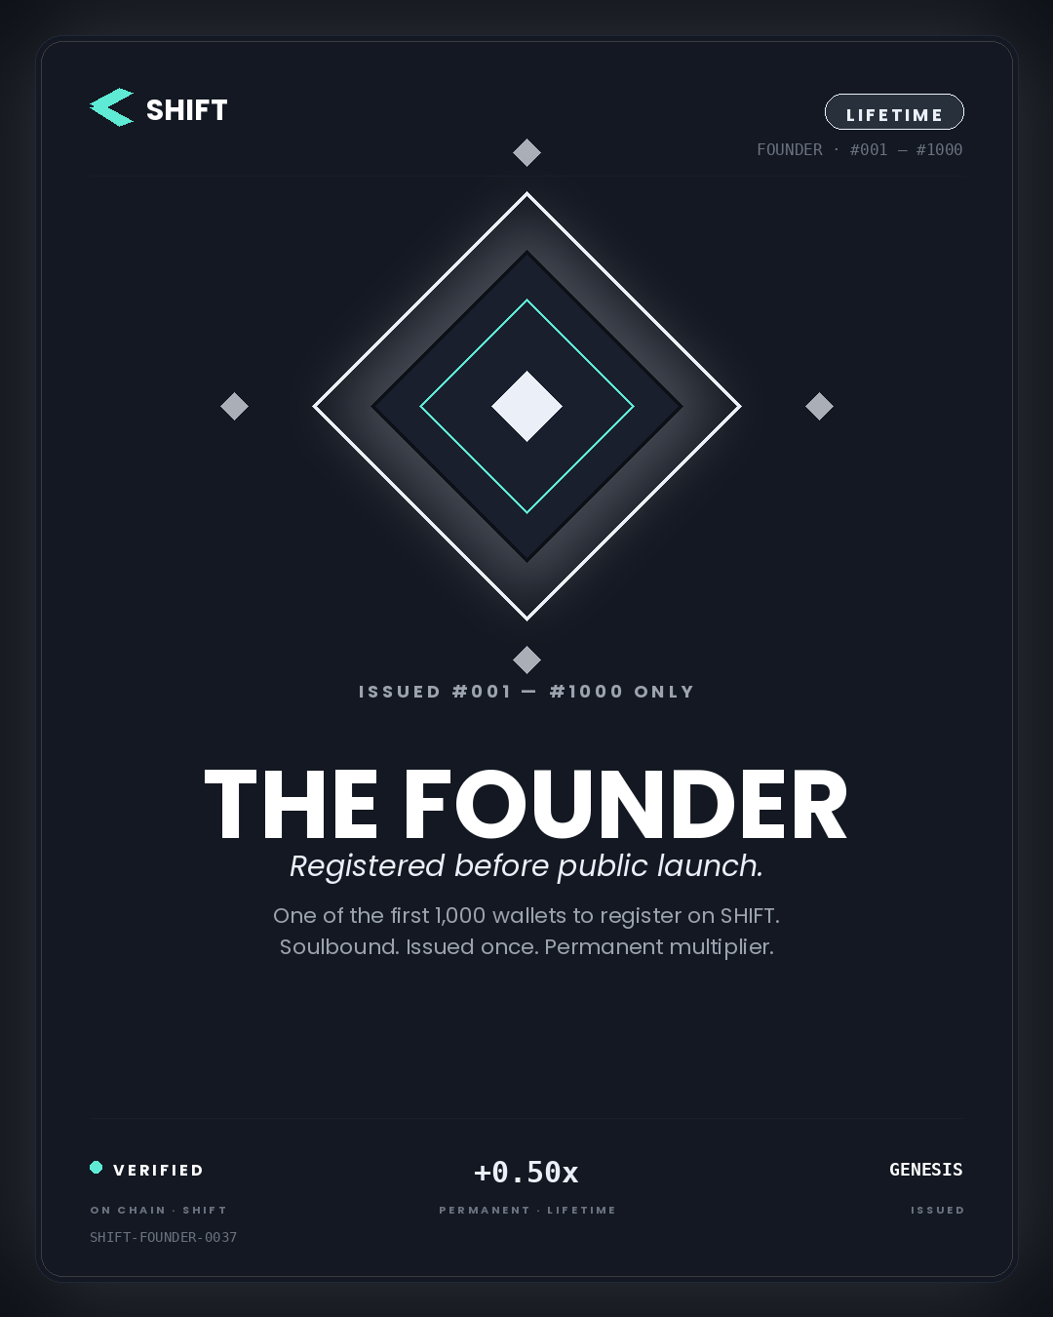 | 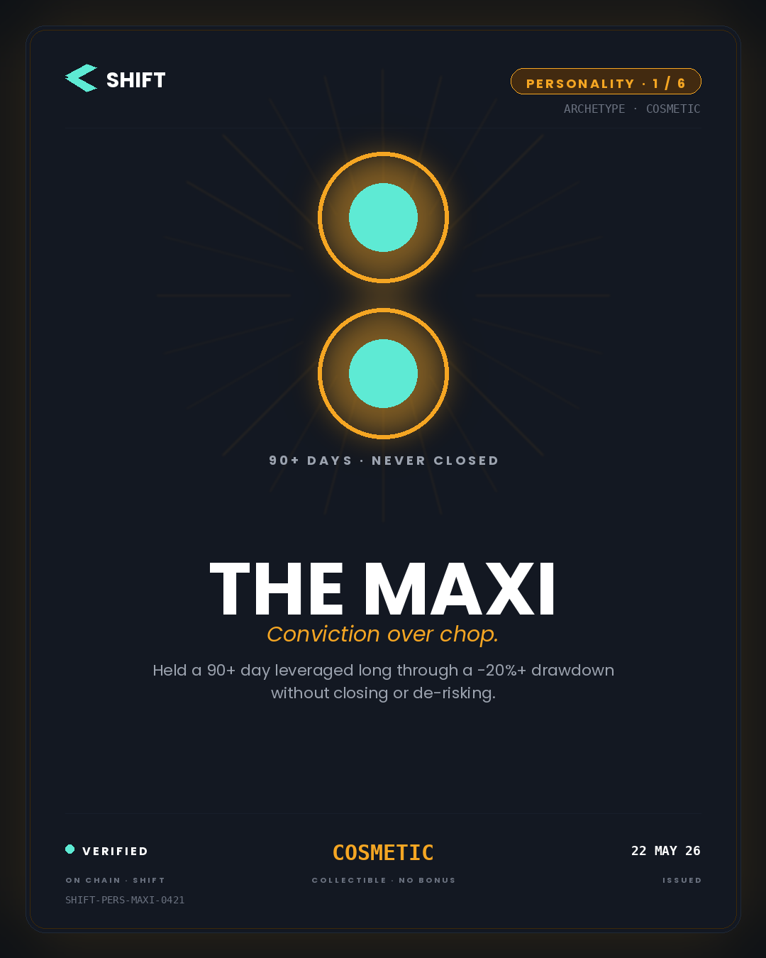
The Founder · Lifetime · paired with Platinum | The Maxi · Personality 1/6 · paired with Amber
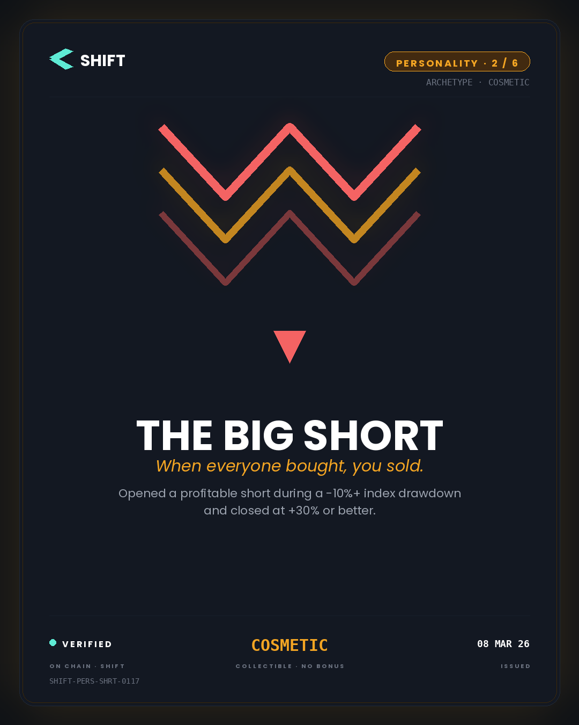 | 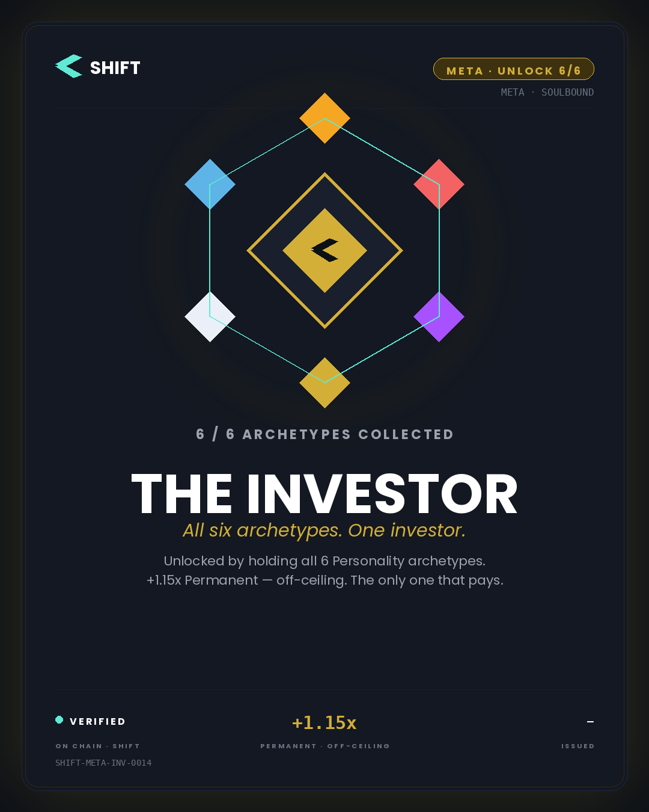
The Big Short · Personality 2/6 · paired with Amber | The Investor · Meta · unlocked at 6/6 · paired with Gold

